## Level Details

### Level 1:

#### Level Summary

Level 1 introduces the player to the basic movement and goals of the game. Tutorial instructions are written on the environment of the level. The player is taught how to interact with the debris, dumpsters, obstacles, and a single enemy.

#### Map

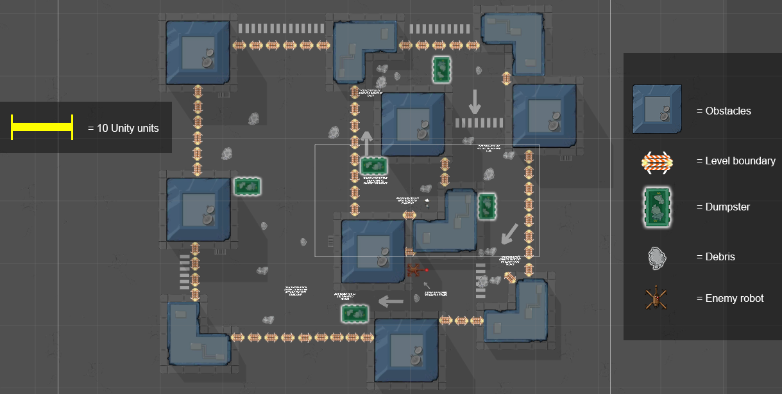

Figure 38: Overview Map of Level 1 in Unity [2]

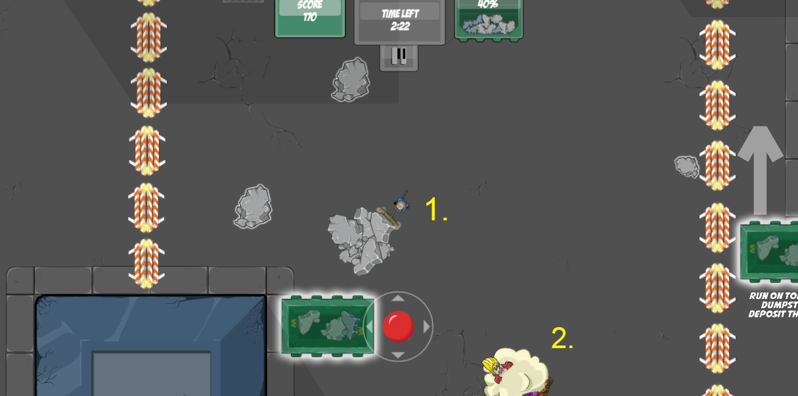

Figure 39: Closer view of Level 1 gameplay [2]

#### Map Description

The level starts with the player in a small alleyway that is blocked off completely except for one exit where the dumpster lies. There are a few pieces of debris that the player is instructed to pick up and turn into the dumpster. The player cannot leave the area without learning how to pick up and turn in debris. The player then moves through a series of alleyways in a spiral-like formation, repeating the actions of picking up and turning in debris. At the end of the spiral, the player encounters a robot enemy and learns how to avoid its fire and how to sweep up and destroy it. As the player reaches the end of the alleyway, they enter a large open space with lots of debris and the conflict cloud forms from the superhero and villain. The player must sweep up the debris and the level ends once they sweep it all up or when they run out of time.

|  |  |  |  |  |  |
| --- | --- | --- | --- | --- | --- |
| Map Label | Event Description | Key Info (e.g. Challenges, Actions) | Approx. Difficulty (1-10) | Approx. Time | Wow? |
| 1 | Sweeping debris into dumpster; visual action word feedback whenever debris is moved to the dumpster | Actions: Sweep up debris into your pile and push it to the dumpster to dispose of it; done on a seconds-to-minutes basis, depending on how large of piles of debris the player wants to stack before turning into the dumpster.  Challenge: Maneuver larger piles of debris to dumpster intact to get more points. | 2 | 0:10 | N |
| 2 | Conflict Cloud that moves around the level randomly and knocks debris around | Actions: Player to keep up with Conflict Cloud to keep track of it, but avoid directly colliding with it.  Challenge: Player wants to keep up with Conflict Cloud to get powerups it drops, but also avoid colliding with it to keep his or her debris pile intact. | 3 | 1:20 | N |

### Level 2:

#### Level Summary

Level 2 reinforces player movement control, debris collection, debris dumping, and interactions with the Conflict Cloud and robot enemies. This level also introduces the speed boost powerup.

#### Map

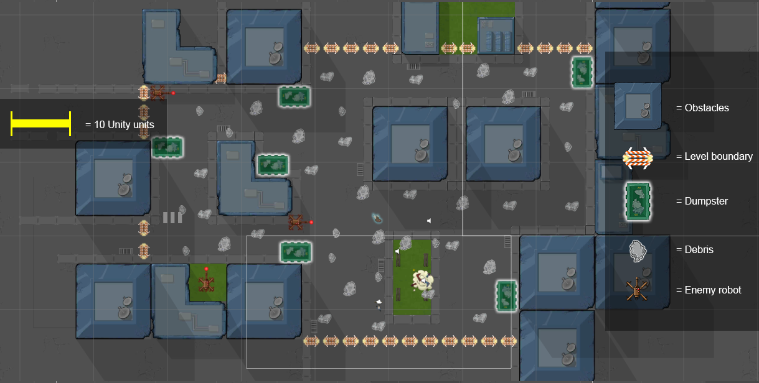

Figure 40: Overview Map of Level 2 in Unity [2]

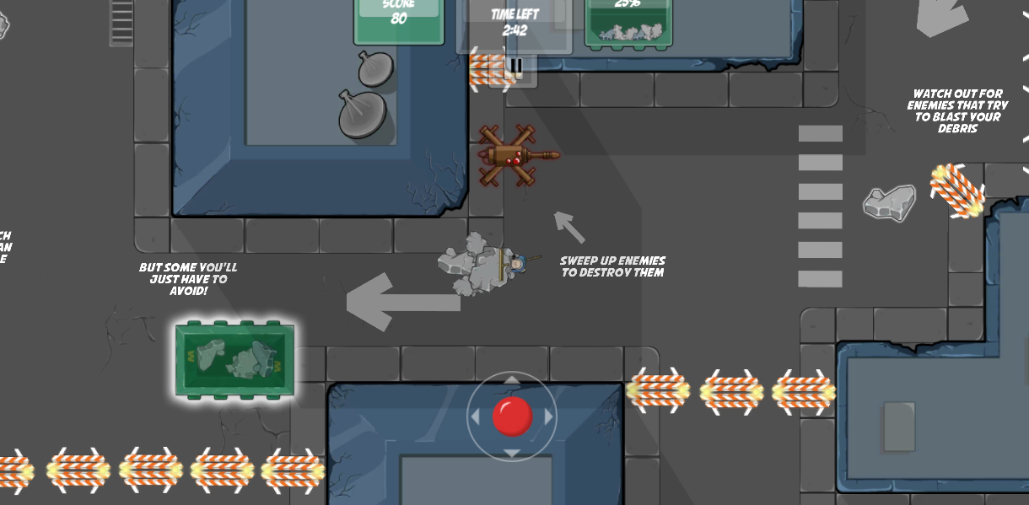

**1**

Figure 41: Closer view of Level 2 gameplay [2]

#### Map Description

The player starts out in an open area with lots of debris and the conflict cloud visible. As the player moves to pick up the nearby debris, they quickly collect a large pile of debris and notice that the player moves more slowly when they are carrying debris. The player sees nearby dumpsters and then turns in their debris. After that the player has the choice to go a number of different directions in the level. All have roughly equal amounts of debris but the left side has multiple robot enemies and a speed boost. When the player moves to the left side, they have the choice to sweep up the enemies and the debris together or just avoid the enemies and sweep up the debris. The level ends when the time runs out or all the debris is picked up.

|  |  |  |  |  |  |
| --- | --- | --- | --- | --- | --- |
| Map Label | Event Description | Key Info (e.g. Challenges, Actions) | Approx. Difficulty (1-10) | Approx. Time | Wow? |
| 1 | Player must avoid robot henchmen lasers so that their debris pile does not get hit and scatter pieces across the level. | Actions: Avoid robot henchmen lasers; sweep up the robots into the pile to dispose of them in the dumpster.  Challenges: Keep the player’s pile from making contact with the robot’s lasers and time the player’s movement so that he or she may sweep the robot itself into the debris pile to dump it in the dumpster. | 4 | 0:20 | Y |

### Level 3:

#### Level Summary

A new level configuration is in the same city environment with a large park area. There are lots of robot enemies and buildings that create hard to navigate alleys. Magnet powerup is introduced.

#### Map

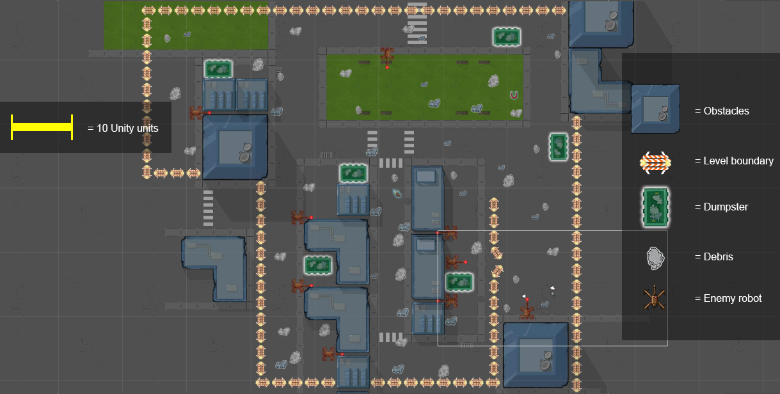

#### Map Description

The player starts with their back to a wall right next to an enemy with multiple debris in front of them. The player sweeps up the enemy and debris and proceeds up the map towards the first dumpster. Just before the player reaches the dumpster, the hero/villain appear and form the conflict cloud. The player then turns in the debris and has to move to the left. They have the choice to go straight left or down to the left. Down to left is a dangerous alleyway where lots of enemies can shoot into it but not be destroyed from inside it. On the outside of the middle alleyway the player can destroy all the enemies robots to make the middle passage easier. If they destroy the enemies first, the player won’t have to spend much time in the alleyway, if they don’t, they’ll likely struggle to hold onto the debris. Outside of the middle alleyway, the player simply has to sweep up debris and enemies and turn them into the dumpsters nearby. The level ends when the time runs out or all the debris is picked up.